NVSL DIVISION: |  | DATE:
LOCATION/POOL: |  | POOL LENGTH: | 25 Meters

Team |  |  | Score |  |  | 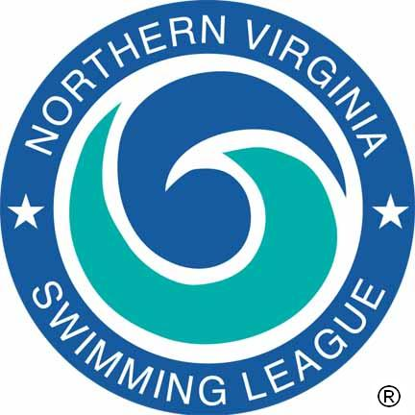 |  | Team |  |  | Score
KEY OFFICIALS | Meet Manager (Div Coord)
KEY OFFICIALS | Referee / Chief Judge
KEY OFFICIALS | Starter
KEY OFFICIALS | Stroke and Turn Judges
KEY OFFICIALS | Side Relay Take-Off Judges
KEY OFFICIALS | Announcer
KEY OFFICIALS | Chief Clerk of Course
KEY OFFICIALS | Chief Timer/Assistant
KEY OFFICIALS | Table Chief
KEY OFFICIALS | Place Recorder / Assistant
KEY OFFICIALS | Verifier / Assistant
KEY OFFICIALS | Computer Operator / Assistant
KEY OFFICIALS | Division Data Coordinator
 | Team Representatives
 | Head Coaches
 |  | Team /  League |  | Event Number | Name(s) |  |  |  |  |  |  | Time
RECORDS

The Northern Virginia Swimming League was founded in 1956 to sponsor competitive swimming and diving events and activities among community swimming pools of Northern Virginia, and to develop in the children participating in this program –
A love for the sport, advanced aquatic skills, teamwork, and the principles of good sportsmanship.

Referee: |  | Date:

