NVSL MEET COVER SHEET
 |  |  |  | 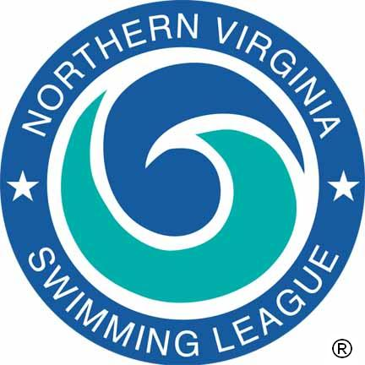
Home: |  |  |  |  |  | Visitor:
Score: |  |  |  |  |  | Score:
Home Team Lanes 1, 3, 5 |  |  |  |  |  | Visiting Team Lanes 2, 4, 6
Pool Length: 25 Meters/Yards
K  E  Y  O  F  F  I  C  I  A  L  S | Referee
K  E  Y  O  F  F  I  C  I  A  L  S | Starter
K  E  Y  O  F  F  I  C  I  A  L  S | Place Recorder/Asst
K  E  Y  O  F  F  I  C  I  A  L  S | Chief Timer/Asst
K  E  Y  O  F  F  I  C  I  A  L  S | Data Entry/Asst
K  E  Y  O  F  F  I  C  I  A  L  S | Announcer
K  E  Y  O  F  F  I  C  I  A  L  S | Stroke and Turn Judges
K  E  Y  O  F  F  I  C  I  A  L  S | Relay Take-Off Judges
K  E  Y  O  F  F  I  C  I  A  L  S | Clerk-Course/Asst
K  E  Y  O  F  F  I  C  I  A  L  S | Marshals
K  E  Y  O  F  F  I  C  I  A  L  S | Team Representatives
K  E  Y  O  F  F  I  C  I  A  L  S | Coaches
 |  | Team /  League | Event Number |  | Name(s) |  |  | Time
RECORDS

The Northern Virginia Swimming League was founded in 1956 to sponsor competitive swimming and diving events and activities among community swimming pools of Northern Virginia, and to develop in the children participating in this program –
A love for the sport, advanced aquatic skills, teamwork, and the principles of good sportsmanship.

Referee: |  | Date:

