NVSL DIVISION XX INDIVIDUAL CHAMPIONSHIPS

Meet Director: |  |  |  |  |  |  |  | 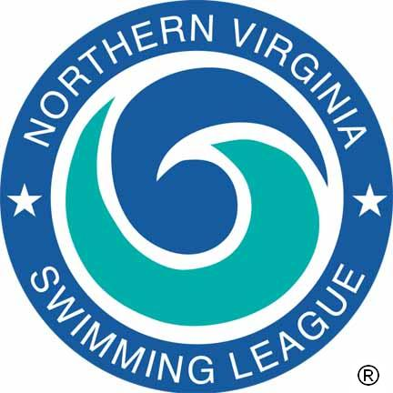
Assistant Meet Director:
Division Data Coordinator:
Location:
Date:
Pool Length: 25 Meters
 |  |  |  | 1st Half |  |  |  |  |  | 2nd Half
K  E  Y  O  F  F  I  C  I  A  L  S | Referee
K  E  Y  O  F  F  I  C  I  A  L  S | Chief Judge
K  E  Y  O  F  F  I  C  I  A  L  S | Starter
K  E  Y  O  F  F  I  C  I  A  L  S | Stroke and Turn Judges
K  E  Y  O  F  F  I  C  I  A  L  S | Announcer
K  E  Y  O  F  F  I  C  I  A  L  S | Chief Timer / Assistant
K  E  Y  O  F  F  I  C  I  A  L  S | Table Chief
K  E  Y  O  F  F  I  C  I  A  L  S | Place Recorder / Assistant
K  E  Y  O  F  F  I  C  I  A  L  S | Computer Operator / Assistant
K  E  Y  O  F  F  I  C  I  A  L  S | Verifier / Assistant
K  E  Y  O  F  F  I  C  I  A  L  S | Chief Clerk-Course
K  E  Y  O  F  F  I  C  I  A  L  S | Team Representatives
K  E  Y  O  F  F  I  C  I  A  L  S | Head Coaches
 |  | Event Number and Description |  |  | Name(s) |  |  |  |  |  | Time
LEAGUE RECORDS

The Northern Virginia Swimming League was founded in 1956 to sponsor competitive swimming and diving events and activities among community swimming pools of Northern Virginia, and to develop in the children participating in this program –

A love for the sport, advanced aquatic skills, teamwork, and the principles of good sportsmanship.

1st Half Referee: |  | Date:
2nd Half Referee: |  | Date:

