Swimtopia Procedures - Swimtopia & HyTek
For Brandywine Barracudas

Last Updated by Brandywine Data Coordinator, 5/2018 (pre-season setup)

Brandywine’s SwimTopia use:
All of the NVSL instructions located on the NVSL website apply to the use of TeamManager and MeetManager software by HyTec (mynvsl.com under Documents/HyTec). Brandywine has converted to SwimTopia (brandywine.swimtopia.com) for jobs, swimmer availability, and swimmer roster and entries. This document provides summary-level SwimTopia procedures for the beginning of the year and for each meet; please maintain these instructions as a living document within GoogleDrive (owned by the brandywinedata@gmail.com account, within the Data Coordinator folder nested within the master team folder owned by the Brandywine Team Manager).

Swimtopia and HyTec: Additionally, many of the HyTec related instructions do not apply to Brandywine due to our use of SwimTopia. The information about setting up meet entries especially is not used; this information is instead supported by SwimTopia imports into TeamManager.

Maintaining instructions: These instructions should be maintained by the data coordinator throughout the year to keep the document evergreen. See the Brandywine GoogleDrive Info file for information about cloud file locations: https://docs.google.com/document/d/1bUiSK2TFTXPvhsTTA32ntrnZQu3miyjxpTq4eiGH7Sg/edit

Contents:
Season Setup: 2
Weekly A-Meet: 4
Weekly B-Meet: 5
Miscellaneous Instructions 6

Season Setup:
At the beginning of each season:

*** Current data coordinator didn’t go through this process as role was inherited early in the season. Input from any other Swimtopia users would be most welcome for this section ***

Swim Team Setup in Swimtopia and TeamManager
The NVSL documents talk about making swimmers inactive in the athlete database -- talk to Team Manager about this. I envision that we will make all swimmers in TeamManager inactive, then perhaps import SwimTopia? Not sure if this will “reactivate” current swimmers or not. May need to do some more research before taking this step. May also just leave all swimmers as they were and manually deactivate those not signed up in Swimtopia.

Meet Setup within Swimtopia
SwimTopia will work better if all the NVSL and FAST B meet data and meet structure is imported into SwimTopia rather than manually entered as this ensures all events and naming conventions match. Everything can be corrected if they don’t match, but best to work early and get all matching at the outset. Coordinate closely with the Team Manager to get the sequence and timing right. Last year the meets were created in SwimTopia so the naming was different than HyTec/NVSL standard. Much easier to draw info from the NVSL data.

The template information is located at mynvsl.com at Documents/Hy-Tek, Documents/Hy-Tec (B Meet) and should be downloaded to the hard drive of the Brandywine Computer. These .zip files can be uploaded under “create new meet” in SwimTopia which will provide the basic structure.

Export all the zip files for each of the A and B meets:
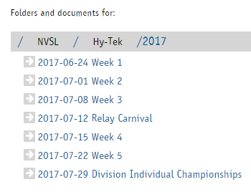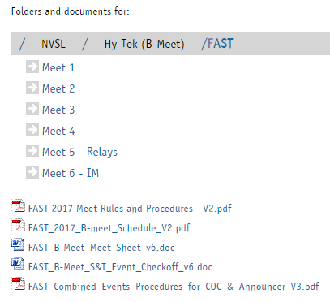
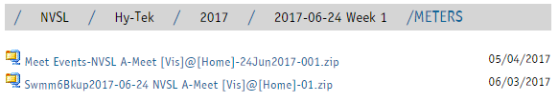
Add Swim Meet in Swimtopia and upload the .zip files for the correct year with the details (you must first log in and manage team):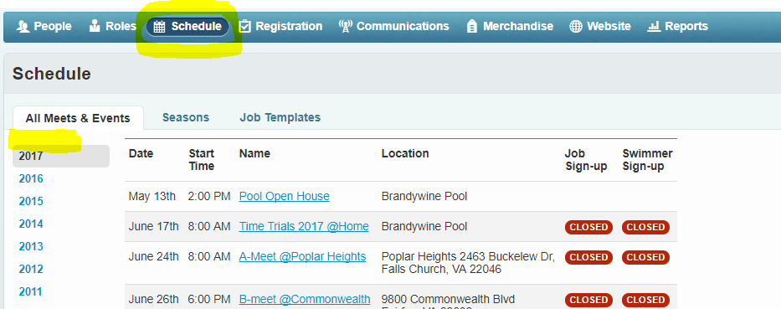
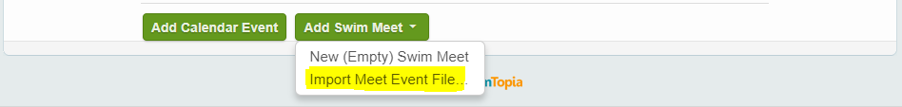

Import Meet Events in TeamManager following NVSL Instructions
- Meet Events downloaded from mynvsl (ideally at the beginning of the season. Filename is Meet Events-NVSL A-Meet [Vis]@[Home]-DDMMM20xx-001.zip)
- Import all first
- Then create subfolders with the same naming convention

Restore MeetManager databases for all A meets following NVSL instructions
- Restore the file from the NVSL website and apply the correct naming convention.
Swmm6Bkup20yy-mm-dd NVSL A-Meet [Vis]@[Home]-01.zip
Folder name: 20yy-mm-dd NVSL A-Meet [Vis]@[Home]

Weekly A-Meet:
Communicate with Coach on when meet is ready:
- Communicate with the Coach as to when the data is fully ready in SwimTopia.
- Do a check of the data to validate that all is good-to-go. Communicate with coach if not.
Swimtopia: Login, Manage Team, Schedule, Choose Meet, Entries, Individual Entries
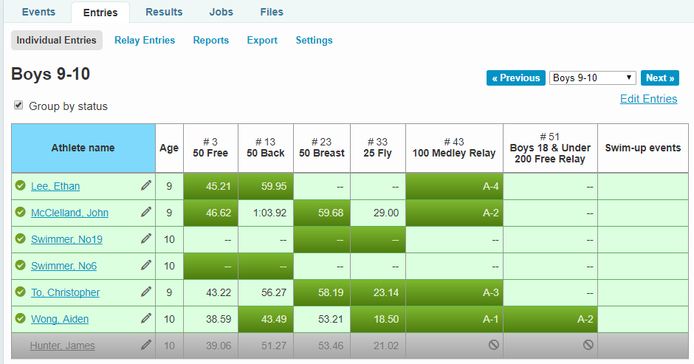
- Each column (event) should have three entries (including NoSwimmers). Each swimmer should have no more than three green entries with one swimmer with four per screen… this is no more than two individuals and two relays per swimmer. Check for all age groups/genders.
- Export the Meet Entries and Team Roster. Right click and choose Save Link As… and save it to the folder that was created to hold this meet (e.g., C:/HyTek/20XX/** Meet/20XX-MM-DD B@XX). Do this for both files.
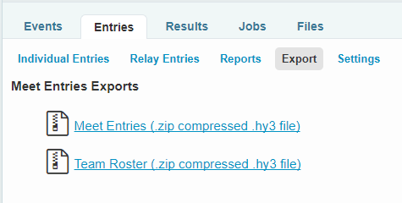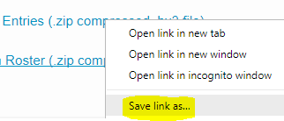
- In TeamManager, File:Import files in the following order:
  - Athlete Rosters file downloaded from SwimTopia
  - Meet Entries
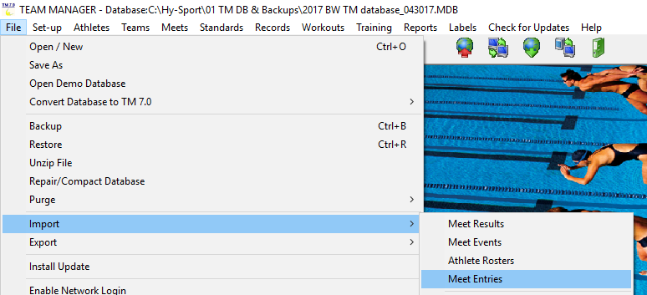

Weekly B-Meet:
Follow same procedures, more or less, from the A-Meet:
- Still check the number of strokes per kid (2 individual + IM max)
- Print a report from MeetManager to check against entry in a stroke in which they placed
  - Open Meet Database from last A Meet (File:Open, or recent files at bottom)
  - Choose Meet Results (Reports:Results). Include the following settings:
    - In Columns/Format replace [blank] with 3 in Top How Many at lower right
    - In Include in Results Tab, uncheck Records, Entry Times
    - In Splits/.../Teams, check Selected Teams and choose Brandywine
    - Include only “B”randywine
    - Choose Select All menu
    - Choose Create Report menu
    - Print/Save or whatever to check against Swimtopia
- Then check against this report for any disallowed entries of placing kids swimming the same stroke in the B meet. Communicate with the coach about how to change if you find one.
- Reset all settings to original and create (then close) a report so future Meet Results Reports aren’t limited to our scoring members.
  - In Columns/Format replace 3 in with [blank]
  - In Include in Results Tab, check Records, Entry Times
  - In Splits/.../Teams, check Selected Teams and choose Brandywine
  - Include All Teams

Do the Exports from Swimtopia, and Imports into TeamManager as per A-Meet

Run everything else as per B-Meet procedures from NVSL

Special note - to print B-Meet labels including Participant/DQ labels, do the following:
Awards to place 17 (or some high number), One label per event, All Swimmers, Participation Award, Include DQ. For swimmers that don’t show, do NOT enter “NS”, just leave time blank.
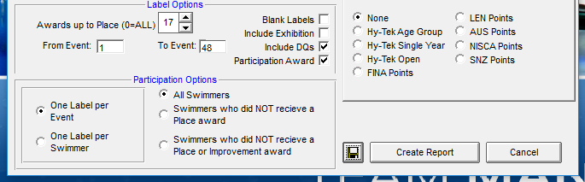

Miscellaneous Instructions
EMailed by Division Coordinator Susan Lee Ruth for Divisionals
For 2018: The rules changed, so any time from meets are acceptable, it is no longer seeded by only A meeting. This was a 2018 rule change for NVSL.
For 2017 Divisionals, if a swimmer has an A-meet time, that is the time they must use for seeding for Divisionals. In order to accomplish this, go back and for all of your A-meets, on your first set up screen, list them as an A meet. Then for Divisionals, mark it also as an A meet then on the last file tab (eligibility rules) click on the box that says restrict entries to same type of meet.
For IMs, you will need to manually put in the B-Meet times.
I will not be able to accept your entries if B-meet times are not filtered out for the other events.
Contact me if this does not make any sense to you.

